**Pizza Sales Analysis**

**KPI’S**

**1. Total Revenue**:

SELECT SUM (total_price) AS total_revenue from pizza_sales;

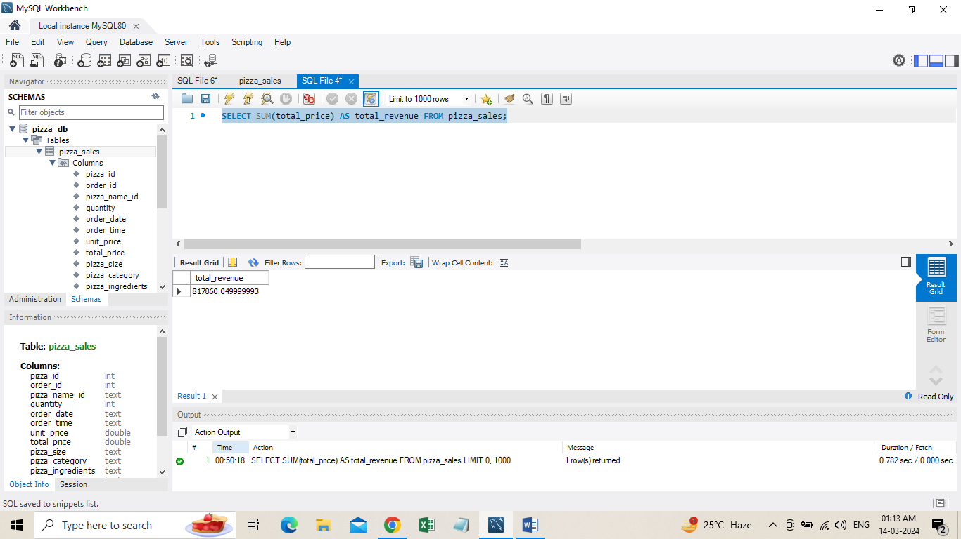

**2. Average Order Value**:

Select SUM (total_price)/ Count (DISTINCT order_id) AS avg_order_value from pizza_sales;

**3**. **Total Pizzas Sold**:

Select SUM (quantity) AS total_pizza_sold from pizza_sales;

**4. Total Orders**:

Select Count (DISTINCT order_id) AS total_order from pizza_sales;

**5. Average Pizzas Per Order:**

Select ROUND (SUM (quantity) / Count (DISTINCT order_id), 2) AS avg_pizza_per_order from pizza_sales;

**Hourly Trend for Total Pizzas Sold**

Select HOUR (order_time) AS order_hours, SUM (quantity) AS total_pizzas_sold from pizza_sales

Groupby HOUR (order_time)

Order by HOUR (order_time);

**Weekly Trend for Orders**

SELECT WEEK (order_date,3) AS WeekNumber, YEAR (order_date) AS Year, COUNT (DISTINCT order_id) AS Total_orders

From pizza_sales

Group by WEEK (order_date,3), YEAR (order_date)

Order by Year, WeekNumber;

**% of Sales by Pizza Category**

SELECT pizza_category, ROUND (SUM (total_price),2) AS total_revenue,

ROUND (SUM (total_price) *100 / (SELECT SUM (total_price) from pizza_sales),2) AS PCT

From pizza_sales

Group by pizza_category;

**% of Sales by Pizza Size**

SELECT pizza_size, ROUND (SUM (total_price), 2) AS total_revenue,

ROUND (SUM (total_price) *100 / (SELECT SUM (total_price) from pizza_sales),2) AS PCT

From pizza_sales

Group by pizza_size

Order by pizza_size;

**Total Pizzas Sold by Pizza Category**

Select pizza_category, SUM (quantity) AS Total_Quantity_Sold from pizza_sales

Where MONTH (order_date) = 2

Group by pizza_category

Order by Total_Quantity_Sold DESC;

**Top 5 Pizzas by Revenue**

SELECT pizza_name, SUM (total_price) AS Total_Revenue

From pizza_sales

Group by pizza_name

Order by Total_Revenue DESC LIMIT 5;

**Bottom 5 Pizzas by Revenue**

SELECT pizza_name, SUM (total_price) AS Total_Revenue

From pizza_sales

Group by pizza_name

Order by Total_Revenue ASC LIMIT 5;

**Top 5 Pizzas by Total Orders**

SELECT pizza_name, COUNT (DISTINCT order_id) AS Total_orders

From pizza_sales

Group by pizza_name

Order by Total_Orders DESC LIMIT 5;

**Bottom 5 Pizzas by Total Orders**

SELECT pizza_name, COUNT (DISTINCT order_id) AS Total_orders

From pizza_sales

Group by pizza_name

Order by Total_Orders ASC LIMIT 5;

